**Assignment No 3**

**-------------------------------------------------------------------------------------------------------------------------------------------------------------------------------------------------------------------------------------------------------------------------------**

* VLookUp Exercise Question

**Worksheet 1: Product & Worksheet 2: Orders**

**1. Use to find the product names for each ProductID in the Orders worksheet.**

**Ans:** 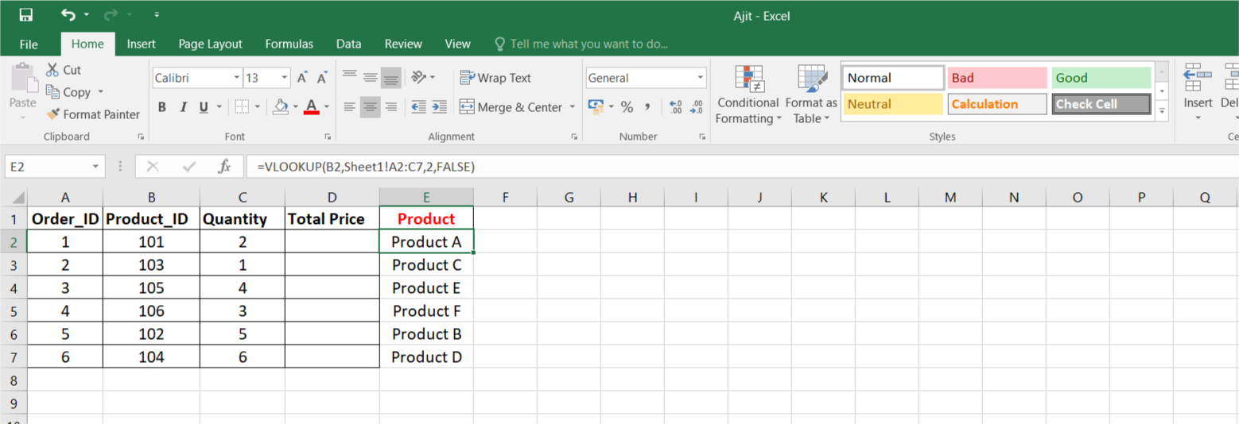

**2. Use VLOOKUP to find the price for each ProductID in the Orders worksheet, then calculate the TotalPrice by multiplying the Quantity by the Product Price.**

**Ans:**

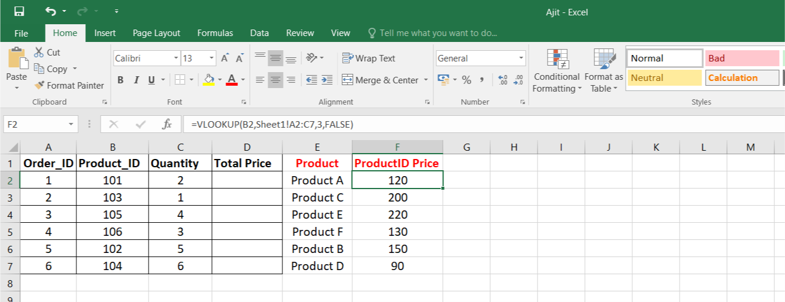

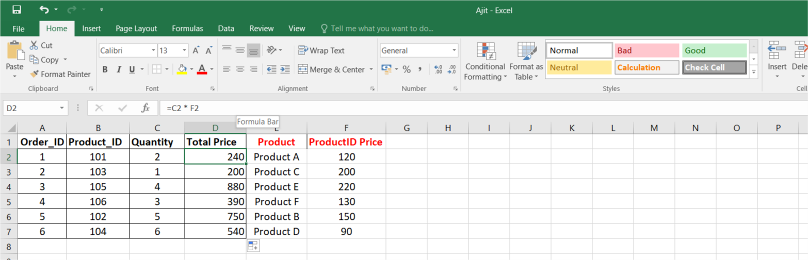

**3. Use VLOOKUP to check if there are any ProductIDs in the Orders worksheet that do not exist in the Products worksheet.**

**Ans:**

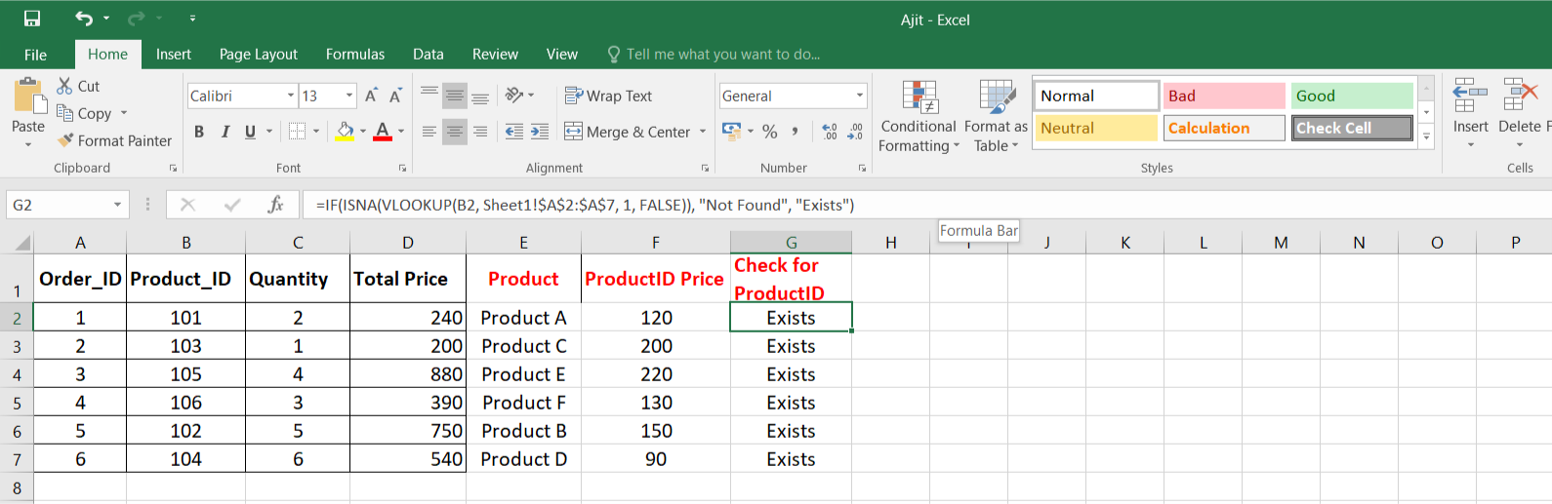

**4. Assume a discount of 10% is given on all products. Use VLOOKUP to find the original price and then calculate the discounted price.**

**Ans:**

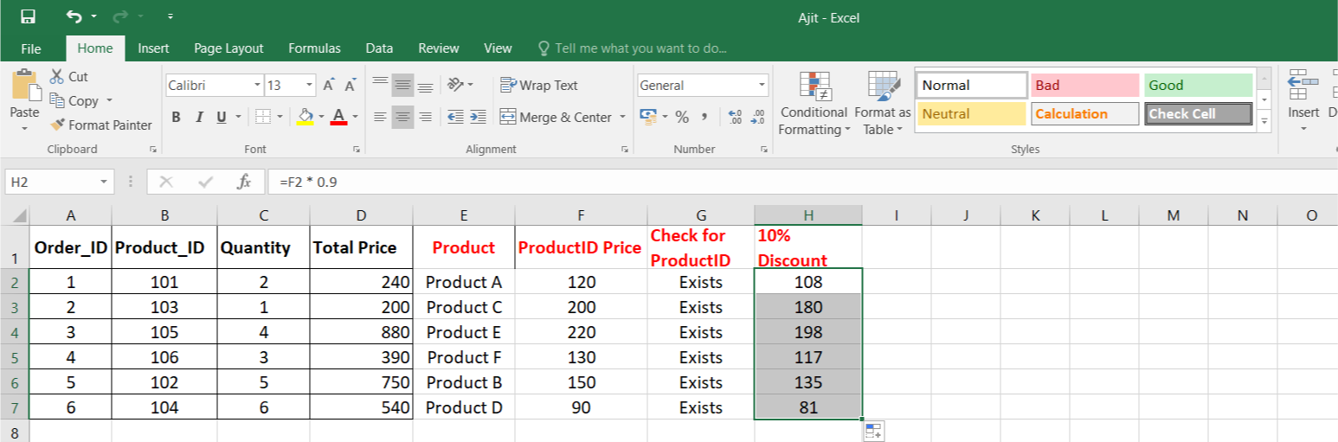

**5. Use VLOOKUP to find the price for each ProductID and then calculate the order value. Find the maximum order value from the list.**

**Ans:**

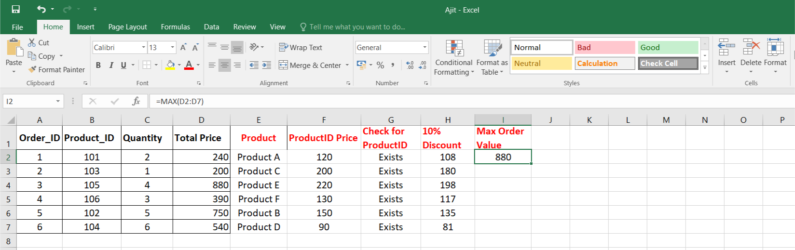

**6. Use VLOOKUP to find out which products from the Products worksheet have not been ordered.**

**Ans:**

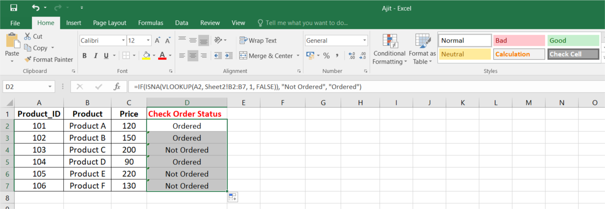

**7. Use to find the Product name and summarize the total quantity sold for each product.**

**Ans:**

